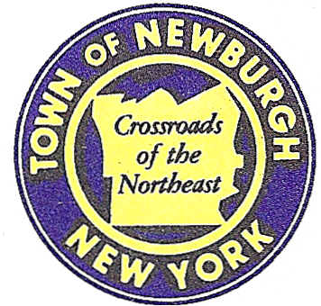

TOWN OF NEWBURGH
--------Crossroads of the Northeast _
OLD TOWN HALL
308 GARDNERTOWN ROAD NEWBURGH, NEW YORK 12550

PLANNING BOARD
JOHN P. EWASUTYN, CHAIRMAN TELEPHONE 845-564-7804
FAX 845-564-7802
E-MAIL: planningboard@townofnewburgh.org

PLANNING BOARD AGENDA

MAY 1, 2014

**PLEASE NOTE: The Planning Board Meeting will start at 7:00 P.M. and all Applicants/Representatives are to be present at that time. The Meeting will be held in the Meeting Room of Town Hall, located at 1496 Route 300, Newburgh NY.**

- Crystal Run Medical Office (2013-18)  1000-1006 Union Avenue, NYS Rte. 300  Sec. 97; Blk. 3; Lot 6, 7, 8.28  Sec. 4; Blk. 1; Lot 72.2 (New Windsor)  Zone: IB  Rep: Dominic Cordisco, Esq.  Drake, Loeb, Heller, Kennedy,  Gogerty, Gaba & Rodd, PLLC  555 Hudson Valley Avenue, Suite 100  New Windsor, NY 12553 | PUBLIC HEARING
- Volkswagen of Newburgh (2013-11)  Route 17K and McDonald Street  Sec. 95; Blk. 1; Lot 53  Zone: IB  Rep: Dominic Cordisco, Esq.  Drake, Loeb, Heller, Kennedy,  Gogerty, Gaba & Rodd, PLLC  555 Hudson Valley Avenue, Suite 100  New Windsor, New York 12553 | SITE PLAN

*WORK SESSION: Project Readiness Discussion scheduled for 5:30 p.m. in the Meeting Room of Town Hall on Thursday, May 1, 2014*

PLANNING BOARD BUSINESS
WORK SESSION

MAY 1, 2014
5:30 P.M.

Discussion:

- Discussion of Solar Ordinance.
- Discussion of Sign Ordinance.

